Cross-quantilogram: USDCHF and USDCAD
Method 20 / daily log returns / expanding quantiles / Alpari D1 full available history

Study setup
Logical pair: USDCHF , USDCAD
Broker symbols: USDCHF_i , USDCAD_i
Snapshot: 2026-11-03_majors_alpari_D1
Timeframe: D1
Matched return window: 1999-01-05 to 2026-11-02 (UTC bar dates)
Matched return count n: 7188
Dropped unfinished last bar dated 2026-11-03 UTC after a tick-volume check against the prior complete day.
Quantiles: expanding window, min history 252 days
tau in [0.05, 0.2]; k=0..10; headline tau=0.05, k=1
Complete matched rows (Excel): USDCHF-USDCAD_CQ_D1.xlsx
Complete matched rows (HTML table): USDCHF-USDCAD_CQ_D1_data.html

Method carried forward
The cross-quantilogram rho_tau(k) measures linkage among centered quantile-hit indicators of matched daily log returns of close, ln(close_t / close_t-1). Quotes are not inverted. At each date t, the tau-quantile uses only returns through t (expanding window) after a minimum history of 252 days. Hits are h_t = 1(r_t < q_t) - tau. rho_tau(k) is the normalized cross-product of h_x,t with h_y,t+k. Levels tau in {0.05, 0.20} and lags k=0..10 are pre-specified; headline is tau=0.05, k=1 both directions. Same-sample Pearson r is a side check. This is not causation and not a trading signal.

Results (headline)
rho_USDCHF->USDCAD(tau=0.05,k=1): 0.006263
rho_USDCAD->USDCHF(tau=0.05,k=1): 0.045615
rho_USDCHF->USDCAD(tau=0.20,k=1): -0.014930
rho_USDCAD->USDCHF(tau=0.20,k=1): 0.032987
Pearson r: 0.304665

CQ table (tau=0.05)
k | rho_USDCHF_to_USDCAD | n_USDCHF_to_USDCAD | rho_USDCAD_to_USDCHF | n_USDCAD_to_USDCHF
0 | 0.14986488 | 6937 | 0.14986488 | 6937
1 | 0.00626278 | 6936 | 0.04561499 | 6936
2 | 0.01705183 | 6935 | 0.02403885 | 6935
3 | 0.00264553 | 6934 | 0.00246232 | 6934
4 | 0.00263656 | 6933 | 0.04918394 | 6933
5 | 0.00622701 | 6932 | 0.02760725 | 6932
6 | 0.02061592 | 6931 | 0.05304701 | 6931
7 | 0.00980863 | 6930 | 0.03142688 | 6930
8 | 0.02419783 | 6929 | 0.0386221 | 6929
9 | 0.00259168 | 6928 | 0.00979744 | 6928
10 | 0.02777987 | 6927 | 0.05301294 | 6927

Conclusion
Headline tau=0.05, k=1 for USDCHF and USDCAD: rho_USDCHF->USDCAD = 0.0063; rho_USDCAD->USDCHF = 0.0456. At tau=0.20, k=1: -0.0149 and 0.0330. Same-day tau=0.05 rho(k=0) = 0.1499. Pearson r = 0.3047. This is quantile-hit linkage, not a trading signal.

Charts
Daily closes

Daily log returns

Cross-quantilogram tau=0.05
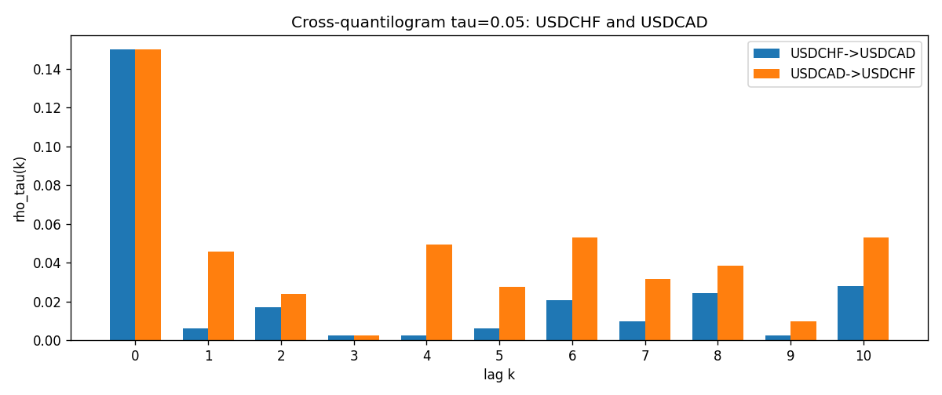

Data report
Matched rows and the CQ sheet are in the sibling Excel workbook named USDCHF-USDCAD_CQ_D1.xlsx. Embedding all rows as a Word table is impractical; this file holds column summaries and the first and last 15 matched rows.
Columns: time, USDCHF_open, USDCAD_open, USDCHF_high, USDCAD_high, USDCHF_low, USDCAD_low, USDCHF_close, USDCAD_close, USDCHF_tick_volume, USDCAD_tick_volume, USDCHF_spread, USDCAD_spread, USDCHF_real_volume, USDCAD_real_volume, USDCHF_log_return, USDCAD_log_return, USDCHF_h_t005, USDCAD_h_t005
Column summaries (matched calculation rows)
column | count | mean | std | min | 25% | 50% | 75% | max
USDCHF_open | 7188 | 1.0975966 | 0.25229688 | 0.72022 | 0.9205375 | 0.989955 | 1.2378 | 1.8219
USDCAD_open | 7188 | 1.2667824 | 0.16892678 | 0.9168 | 1.1183975 | 1.298465 | 1.3720475 | 1.6183
USDCHF_high | 7188 | 1.1028875 | 0.2540352 | 0.73305 | 0.924845 | 0.993545 | 1.242375 | 1.8313
USDCAD_high | 7188 | 1.2716804 | 0.16888565 | 0.9336 | 1.12285 | 1.30387 | 1.37646 | 1.619
USDCHF_low | 7188 | 1.0924772 | 0.25071604 | 0.08565 | 0.91725 | 0.9863 | 1.23155 | 1.8121
USDCAD_low | 7188 | 1.2622243 | 0.16896256 | 0.9056 | 1.114065 | 1.293535 | 1.3677775 | 1.6102
USDCHF_close | 7188 | 1.0975873 | 0.25219296 | 0.72025 | 0.920805 | 0.98995 | 1.2379 | 1.8217
USDCAD_close | 7188 | 1.2667976 | 0.16890032 | 0.916 | 1.118075 | 1.29844 | 1.372365 | 1.6137
USDCHF_tick_volume | 7188 | 74305.244 | 113479.97 | 1 | 12787.25 | 40220 | 70419.75 | 858589
USDCAD_tick_volume | 7188 | 81017.898 | 147302.44 | 1 | 5560 | 40941.5 | 71627 | 1410818
USDCHF_spread | 7188 | 26.050501 | 24.7086 | 0 | 5 | 16 | 50 | 100
USDCAD_spread | 7188 | 23.4399 | 18.261108 | 0 | 9 | 17 | 40 | 60
USDCHF_real_volume | 7188 | 2.3284369e+10 | 8.9116261e+10 | 0 | 0 | 0 | 0 | 1.9331921e+12
USDCAD_real_volume | 7188 | 1.8376704e+10 | 9.6688094e+10 | 0 | 0 | 0 | 0 | 2.5751613e+12
USDCHF_log_return | 7188 | -7.133e-05 | 0.00659527 | -0.19545699 | -0.0033544 | 8.077e-05 | 0.00332477 | 0.09051364
USDCAD_log_return | 7188 | -1.556e-05 | 0.00514382 | -0.03859748 | -0.00283746 | 4.44e-05 | 0.00272629 | 0.03436319
USDCHF_h_t005 | 6937 | -0.01655615 | 0.17980551 | -0.05 | -0.05 | -0.05 | -0.05 | 0.95
USDCAD_h_t005 | 6937 | 0.00203979 | 0.2221233 | -0.05 | -0.05 | -0.05 | -0.05 | 0.95
First 15 matched rows (selected columns)
time | USDCHF_log_return | USDCAD_log_return | USDCHF_h_t005 | USDCAD_h_t005
1999-01-05 | 0.0039424743 | -0.010131666 | nan | nan
1999-01-06 | 0.013605652 | -0.0003306769 | nan | nan
1999-01-07 | -0.0093883841 | 0.0015202092 | nan | nan
1999-01-08 | 0.011040268 | -0.0020495197 | nan | nan
1999-01-11 | 0.0052963193 | -0.0035137769 | nan | nan
1999-01-12 | -0.0098275602 | 0.0066194721 | nan | nan
1999-01-13 | -0.018259701 | 0.0045420214 | nan | nan
1999-01-14 | -0.0024256692 | 0.0069376546 | nan | nan
1999-01-15 | 0.01794228 | -0.0056905671 | nan | nan
1999-01-18 | -0.0031856384 | 0.00098344542 | nan | nan
1999-01-19 | -7.2518946e-05 | 0.002748513 | nan | nan
1999-01-20 | 0.0072259871 | -0.0059646885 | nan | nan
1999-01-21 | -0.0038232689 | -0.0042823796 | nan | nan
1999-01-22 | -0.0001445609 | 0.0025057712 | nan | nan
1999-01-25 | 0.0024546976 | 0.00085579808 | nan | nan
Last 15 matched rows (selected columns)
time | USDCHF_log_return | USDCAD_log_return | USDCHF_h_t005 | USDCAD_h_t005
2026-10-13 | -0.0024955621 | -0.0046395653 | -0.05 | -0.05
2026-10-14 | 0.0029388325 | 0.0015184751 | -0.05 | -0.05
2026-10-15 | -0.0097855323 | -0.0036101503 | -0.05 | -0.05
2026-10-16 | -0.0036230826 | -0.0034322068 | -0.05 | -0.05
2026-10-19 | 0.0036351779 | -0.0018835331 | -0.05 | -0.05
2026-10-20 | -0.0026281224 | -0.0037066008 | -0.05 | -0.05
2026-10-21 | -0.00040027413 | -0.00084691787 | -0.05 | -0.05
2026-10-22 | -0.0048036381 | -0.0026307268 | -0.05 | -0.05
2026-10-23 | 0.005652514 | 2.85545e-05 | -0.05 | -0.05
2026-10-26 | 0.0018407959 | 5.7106554e-05 | -0.05 | -0.05
2026-10-27 | 0.0026100526 | 0.0025379458 | -0.05 | -0.05
2026-10-28 | -0.0010142111 | -0.0038379274 | -0.05 | -0.05
2026-10-29 | -0.0048680164 | -0.00011436495 | -0.05 | -0.05
2026-10-30 | 0.00071594559 | -0.0010298736 | -0.05 | -0.05
2026-11-02 | -0.0071459744 | 0.00061519094 | -0.05 | -0.05

